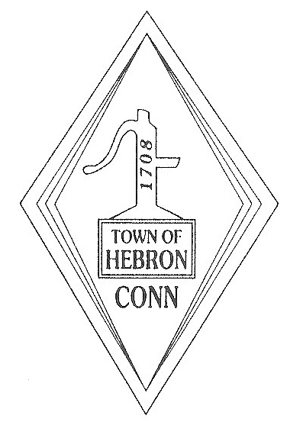TOWN OF HEBRON

Revenue Collection Department
15 Gilead Street
Hebron CT 06248-0134

Phone 860 228-5971 ext 146 Fax 860 228-4859
Office hours: Mon.—Wed. 8:00 am—4:00 pm Thurs. 8:00 am—6:00 pm Friday 8:00 am—1:00 pm

The following is the CORRECTED Press Release we would like to have in the River East News Bulletin in the Hebron section. The Press Release is different from the Legal Notice we are running.

If possible, to be run on 2 separate occasions:
July 2, 2021
July 9, 2021

Please let me know if you have any issues or questions.

Thank you very much and have a great day!
Adrian MacLean

The Revenue Collector for the Town of Hebron reminds taxpayers Tax Bills will be MAILED June 28th, and may be paid July 1, 2021 through August 2, 2021. The bills are for taxes levied on the Grand List of October 1, 2020. Real Estate tax bills over $250 are due and payable in two equal installments on July 1, 2021 and January 1, 2022. Motor Vehicle, Personal Property in addition to Real Estate bills under $250 will be due in a single installment. Real Estate bills due in two installments, please remember the July bill is the only bill you will receive. It has payment coupons for both July 2021 and January 2022. If you feel you should have received bill and have not by July 9, please contact our office to obtain a copy. State Statutes dictate that failure to receive a bill does not invalidate the amount due or when it will be considered delinquent.

Taxes may be paid through August 2, 2021 without penalty. Payments received/postmarked August 3rd or later will be subject to interest retroactively to the July 1st due date in accordance with Connecticut General Statutes. Initial interest starting October 3rd is 3% of the principle due with a minimum of $2.00 per tax account.

Checks are made payable to: Town of Hebron. Payments may be mailed to: Tax Collector, 15 Gilead Street, Hebron, CT 06248. A drop-off box is located on the lower level, south side of the building for payments. Please see the town website www.hebronct.com for on-line payment options and instructions.

The Collector’s office is located in the lower level of the Town Hall at 15 Gilead Street. Our hours are Monday to Wednesday 8:00am to 4:00pm, Thursday 8:00am to 6:00pm, and Friday 8:00am to 1:00pm. Additionally, the Tax and Assessor’s Office is closed for lunch Monday – Thursday from 12:30 – 1:15.

The Town of Hebron will observe Independence Day on July 5, 2021. Through press releases and our website we will keep you posted of any updates/changes. Have a happy, fun and safe summer!

