For Public Press Release/Posting

Dear Sir or Madam:

This letter is to introduce Asher of eQuality Valuation Services LLC, the firm that has been hired to assist the Assessor and the Town of Hebron in the completion of the 2026 Revaluation.

Asher will be taking photographs and inspecting Residential and Commercial buildings where required. Your cooperation will be greatly appreciated.

Asher’s vehicle will have eQuality Valuation Services magnets. Should you have any questions, please call the Assessor’s Office at (860) 228-5971x147.

Sincerely,

Suzanne Topliff
Assessor

Automobile | Color | 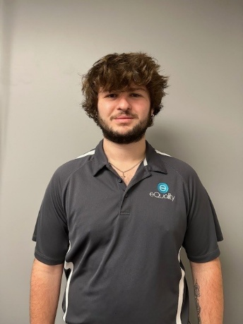
2007 Toyota Avalon | Grey

eQuality Valuation Services (203) 346-1000

